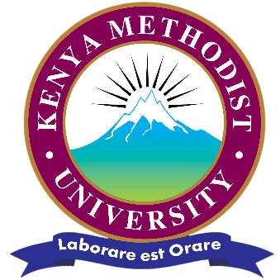
School of Medicine and Pharmacy Compliant with Regulatory Standards- KMPDC Report 2026
The Kenya Methodist University (KeMU) School of Medicine and Pharmacy continues to strengthen its position as one of Kenya’s leading institutions for medical training, distinguished by its commitment to academic excellence, regulatory compliance, innovation and the holistic development of future healthcare professionals. The School’s recent joint inspection by the Kenya Medical Practitioners and Dentists Council (KMPDC) and the Commission for University Education (CUE) reaffirmed its standing as a fully compliant medical school and approved the expansion of its student admissions capacity, reflecting the confidence that the regulators have in the institution’s ability to deliver quality training.
The current joint inspection of the School of Medicine and Pharmacy by KMPDC and CUE provide the most accurate reflection of the School’s standing and reflects the correct status. The report of the assessments confirmed that the School remains compliant with established standards and continues to provide quality medical training in accordance with national and regional regulatory requirements.
Since admitting its pioneer cohort of medical students in 2011 in Bachelor of Medicine and Bachelor of Surgery, the School has admitted students every academic year and has successfully graduated eight cohorts of medical doctors who are serving in healthcare institutions across Kenya and beyond. This remarkable journey reflects the University’s unwavering commitment to producing competent and ethical healthcare professionals.
This commitment was reaffirmed during the Joint Pre-Inspection Exercise conducted by the Kenya Medical Practitioners and Dentists Council and the Commission for University Education in March 2026, where the School attained an overall compliance score of 80.05 per cent, placing the School within the category of FULL COMPLIANCE. The assessment further approved the University to continue offering the Bachelor of Medicine and Bachelor of Surgery (MBChB) programme with an expanded admissions capacity. The university commits to adherence to training standards and continuous quality improvement.

As the first private medical school to be accredited in Kenya, KeMU has played a pioneering role in advancing medical training and contributing to the development of the healthcare workforce both nationally and internationally.
The School’s commitment to quality is reflected in its strong adherence to the standards established by the Kenya Medical Practitioners and Dentists Council (KMPDC), the Commission for University Education (CUE), East African Community Medical and Dental Regulatory Council and other relevant professional and regulatory bodies. Through continuous quality improvement in academic programmes, faculty development, clinical training partnerships, infrastructure, research and student support systems, the University has consistently demonstrated its dedication to maintaining the highest standards in medical training.
The School’s success is built upon a robust academic environment supported by qualified faculty, modern learning resources, established clinical training and a culture of continuous quality improvement. Students benefit from rigorous academic training, practical clinical exposure, research opportunities, mentorship programmes and leadership development initiatives that prepare them to excel in an increasingly dynamic healthcare landscape.
At KeMU, medical education extends beyond the classroom and hospital wards. Guided by the University’s philosophy, the School embraces a holistic approach that nurtures intellectual growth, professional competence, ethical leadership, spiritual development and service to society. This integrated model ensures that graduates emerge not only as skilled medical practitioners but also as compassionate professionals equipped with the character, integrity and values required to make meaningful contributions to healthcare systems and communities.
Over the years, KeMU graduates have distinguished themselves in medical practice, research, public health, specialist training and healthcare leadership across Kenya and beyond. Their achievements continue to reflect the quality of education and professional formation that define the University’s medical training programmes.
Looking ahead, KeMU remains committed to advancing excellence in medical training through innovation, strategic partnerships, research, technological advancement and continuous enhancement of the student learning experience. The University will continue to uphold the highest standards of quality and professionalism as it fulfils its mission of training competent and ethical healthcare professionals.

